**LESSON SUMMARY**

| **Program:** Yuexuele Little Warriors  **Name:** ………………………………………… | **Lesson:** 1 & 2  **Level:** N1 |
| --- | --- |

| **Lesson overview** |
| --- |

| **Unit 1: 小鸟**  **Lesson 1 & 2** |
| --- |

**Vocabulary**:

| 小鸟  /xiǎo niǎo/ | (名) | chú chim non |
| --- | --- | --- |
| 飞  /fēi/ | (动) | bay |
| 朋友  /péngyou/ | (名) | bạn bè |
| 点点头  /diǎndiǎn tóu/ |  | gật đầu |

| **Homework** |
| --- |

1. **Scan to play.** 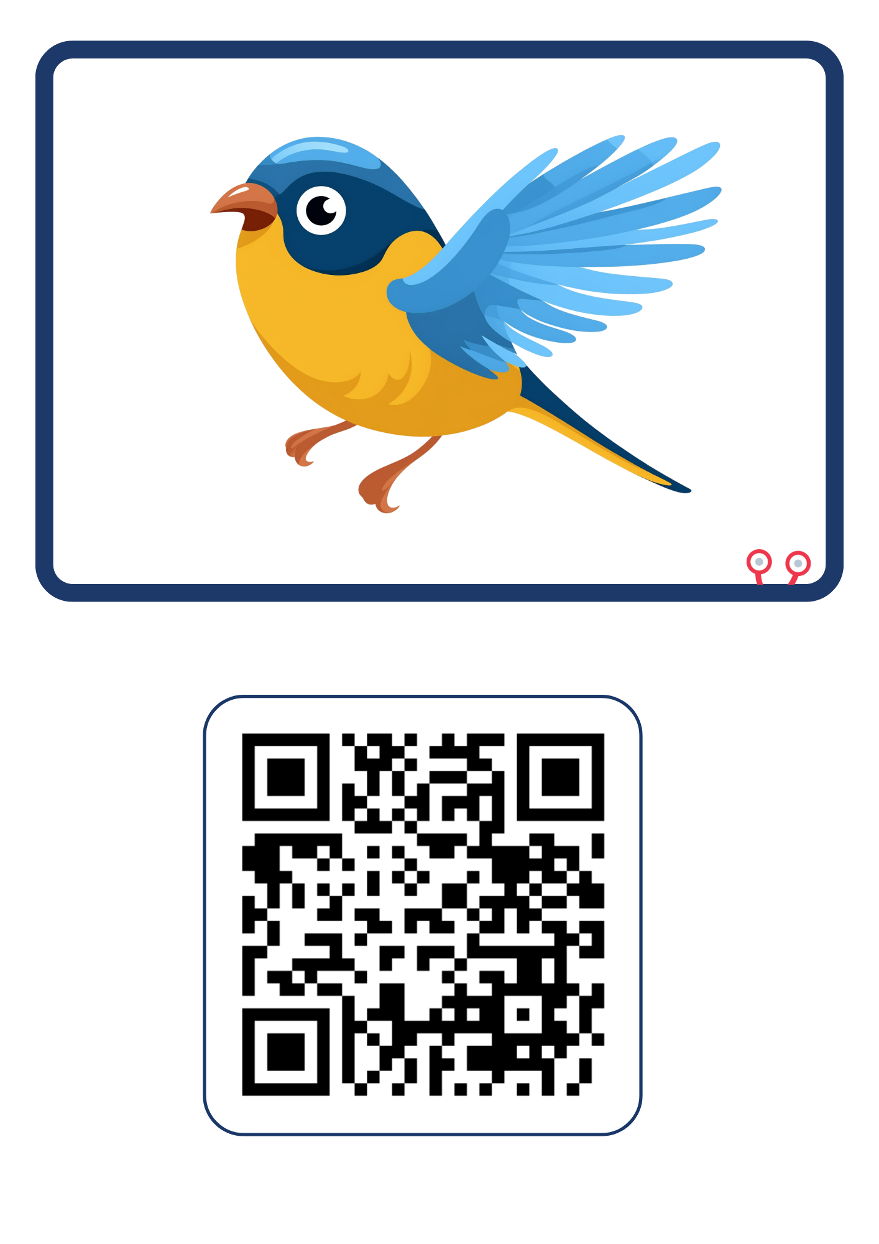

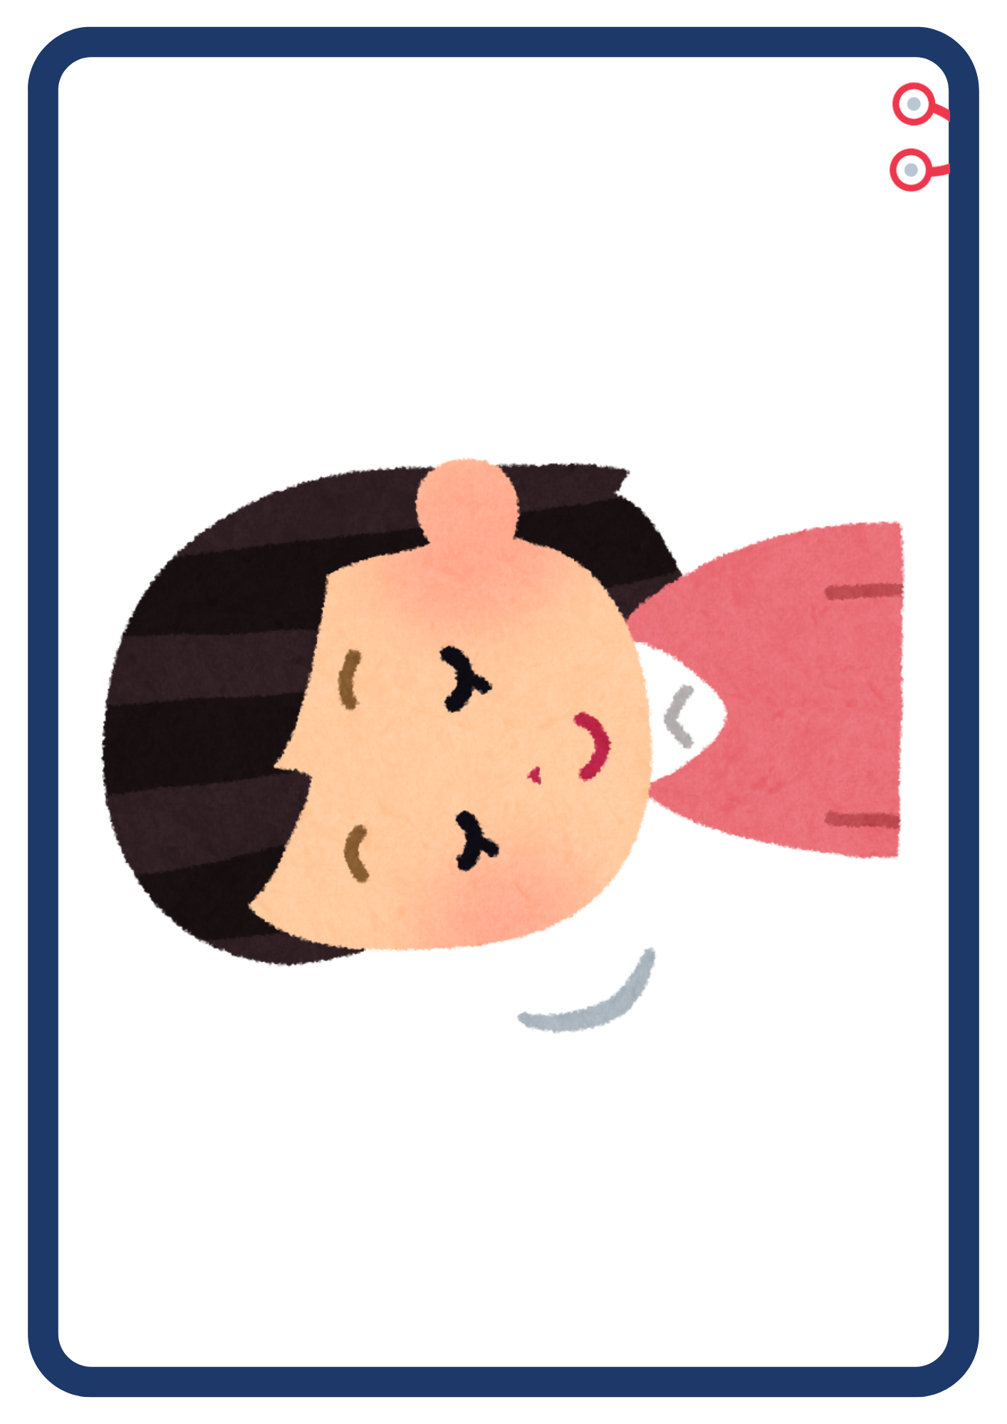

1. **Color the pictures.**